SUBJECT: GEOGRAPHY
CLASS: VI
Week | 1
Day | 1 | Book: Voyage Geography  Read chapter#5  Prepare a weather report for three consecutive day, try to record all the following meteorological information; Temperature, Humidity, Pressure, Wind  (You may collect information from the internet)  Day Date Weather Conditions  Morning Evening
 | 2 | Book: Discovering Bangladesh  Read Chapter#11  Learn the given words and make one sentence for each.  - Ecology- the relationship between the environment and the living organisms  - Cane- the stem of a plan used to make furniture  - Harbor- port for ships  - Livelihood- source for income  - Cold storage- refrigerated storage for preservation  - Raft- a flat float usually made from logs  - Trawler- a kind wooden boat used for catching fish
 | 3 | Book: Discovering Bangladesh  Read Chapter#12  Learn the given words and make one sentence for each.  - Ethnic- distinct cultural group of people  - Diversity- variation  - Ballads- poems  - Contemporary- modern style  - Habitat- the environment in which organisms live
Week | 2
Day | 1 | Book: Voyage Geography  Read chapter#5  Draw the diagram to show a mercury barometer and a hygrometer  Q. Explain a hygrometer works.
 | 2 | Book: Discovering Bangladesh  Read Chapter#11  Learn the given words and make one sentence for each.  - Contaminated- effected by pollutants  - Residue- something that remains after other parts have been removed  - Apiculture- bee cultivation  - Compost- natural fertilizer, usually made from organic waste  - Commercial- anything done in large scale  - Geotextile- fabric that will degrade in nature  - Aquaculture- cultivation of marine plants or animals
 | 3 | Map work  World Map  Label and color the World map with seven continents, five oceans, six countries, six capital cities, two seaports and two mountains. Draw five lines of latitude and the Prime Meridian.  Provide a key box, the cardinal directions, scale and title for the map.
Week | 3
Day | 1 | Book: Voyage Geography  Read chapter#16 (Antarctica)  Label the map from pg#134 (as discussed in the class)  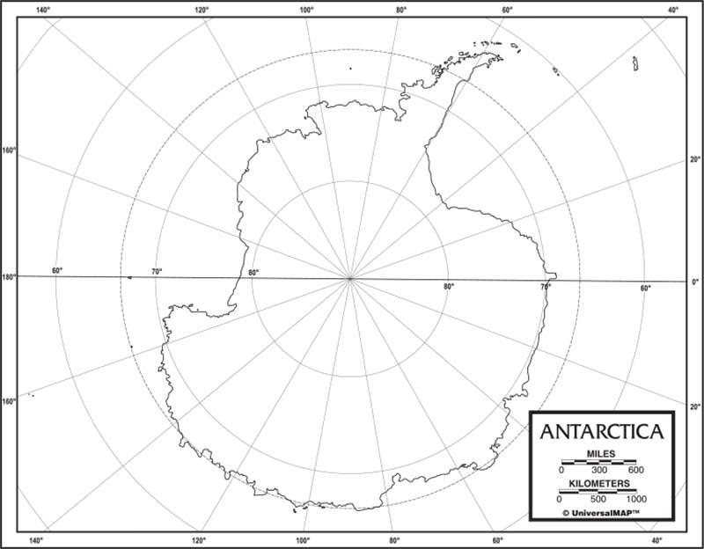
 | 2 | Book: Discovering Bangladesh  Read Chapter#12  Learn the given words and make one sentence for each.  - Intermingle- to mix together  - Dwelling- housing that someone lives in  - Census- official counting population every ten years  - Animism- worship of objects  - Assimilating- collecting together  - Dialect- language used in a particular area
 | 3 | Map work  Bangladesh Map  Label and color the map of Bangladesh with the eight divisions, sixteen districts, five important rivers, three seaports, and two airports.  Provide a key box, the cardinal directions, scale and title for the map.

