Week 3- worksheet 1
Class VII (B1/B2) Chemistry
Electrolysis & Extraction of metals
- Give definitions of the following with examples :
Oxidation , reduction reaction, active electrode, inert electrode.
- Why hydrogen is given off during the hydrolysis of a highly reactive metals (NaCl)? Take hint from the diagram below.
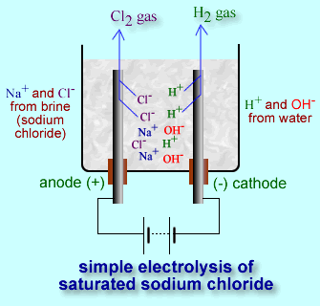

Worksheet 2
- Give some applications of electrolysis.
- Complete the following
When solutions of reactive metal compounds are electrolyzed __________ is formed at the cathode, not the metal. Electrolysis is used in industry to extract reactive _____, and to purify ________.
- What is an Ore? Give some examples of Ores.

Worksheet 3
- What is roasting of Ores? Give an example with proper reactions.
- Write word and symbol equations to show what happens when lead sulfide is roasted in air.
- Why it is important to stop SO₂ gas escaping into the atmosphere?
- Will Tin (Sn) react with FeCl₂ or CuCl₂? Give explaination.

